|  |
| --- |
| **Mathematics for Data Science 2023/24** |

**Week- Linear Algebra – Matrix Operations in Data Science**

**Answer the following questions**

**State whether true or false.**

1. Random Number matrix has numbers drawn at random from a distribution. T/F

2. A diagonal matrix has all 1s on all the off- diagonal elements. T/F

3. A triangular matrix has all zeros in the main diagonal. T/F

4. Identity matrix has all 1s in the diagonal. T/F

Solve the following questions.

1. Find A + B if

Solution:

2. 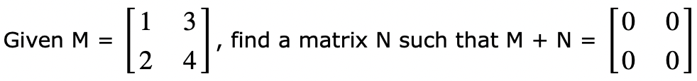

Solution:

3. Calculate A(BA), if

Solution:

4. Solve the following set of equations through matrix inversion method and Gauss Jordan Elimination

2x + 3y − z = 9, x + y + z = 9, 3x − y − z = −1

Solution: x =2 , y = 3, z = 4